|  |  |
| --- | --- |
| EGC_Black | Student Name \_\_\_\_\_\_\_\_\_\_\_\_\_\_\_\_\_\_\_\_\_\_\_    **Eastern Goldfields College**  Mathematics Essentials 2016  Investigation 4 – Packaging and Proportions  1 |

**DUE DATE**: \_\_\_\_\_\_\_\_\_\_\_\_\_\_\_\_\_\_\_\_\_\_\_\_\_\_\_\_\_ **TOTAL MARKS**: 47

This investigation is a take-home task worth 5% of your semester mark.

**PART A [21 marks] - CAPACITY**

**Question 1 (4 marks: 3, 1)**

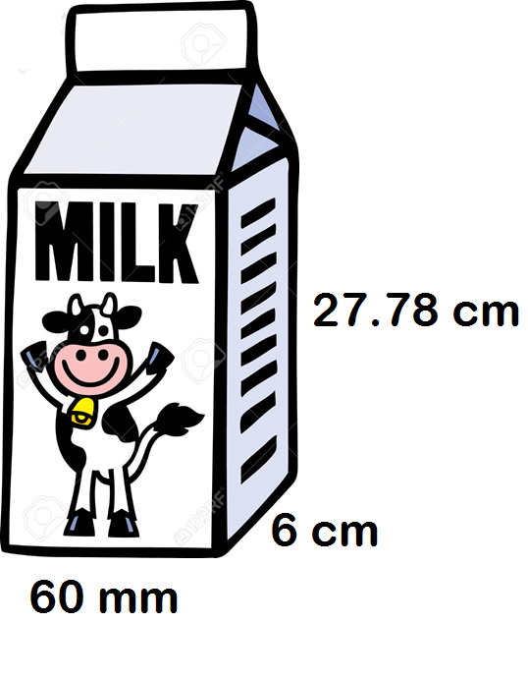

Milk is filled to here.

1. Calculate the volume of the milk carton   
   shown in the diagram on the right. Round  
   your answer to the nearest whole.   
   Show your working.
2. What is the capacity of this milk carton?

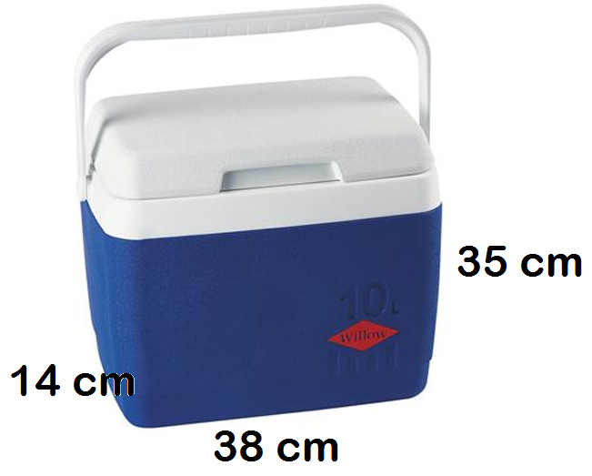**Question 2 (2 marks)**

How many milk cartons can you fit into the Esky shown. Show your working.

**Question 3 (3 marks)**

If the milk carton holds 5½ serves. How many millilitres is in a serve? Round to the nearest ten.

**Question 4 (12 marks: 3, 2, 2, 5)**

To make the drink called Olim, 5% of the ingredients is milo and 95% is milk.

1. One glass is filled with Olim and has a capacity of 420 mL.
   1. How many mL of the glass would be milo? (2 marks)
   2. If 1 mL = 1 gram, how many grams of milo is required? (1 mark)

1. If a teaspoon holds 5 grams, how many teaspoons of Milo is required to make 1 drink? Round to the nearest teaspoon.

1. What proportion of the drink, as a simplified fraction, is milk?

1. John is having a party of 27 guests. Each guest is having one glass of Olim.   
   1. How much milk is required to cater for the guests? (1 mark)
   2. How much milo is required to cater for the guests? (1 mark)
   3. How many cartons of milk will John need to purchase to cater for his guests? (2 marks)
   4. If each carton costs $1.75, how much will it cost John? (1 mark)

**PART B [26 marks] - PACKAGING**

**Question 1 (10 marks: 2, 2, 2, 1, 2, 1)**

Find the volume of each of the shapes below.

|  |  |
| --- | --- |
|  |  |
|  |  |
|  |  |
|  |  |
|  |  |
|  |  |

**Question 2 (8 marks: 4, 4)**

Below is shipping carton along with its dimensions. The volume of this shipping carton  
is 27 000 cm3.

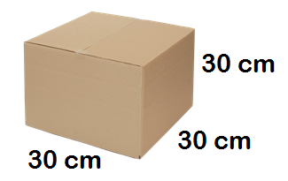

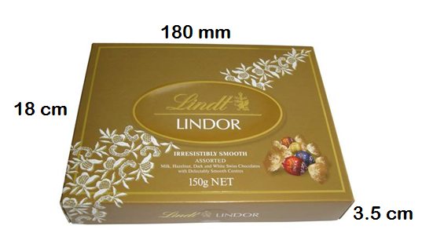

1. Lindt boxes in a shipping carton.  
   1. Draw a diagram, of how the Lindt boxes would be packaged within the shipping carton. Ensure you clearly label or indicate or explain:
      * The number of Lindt boxes in a row
      * How the boxes would be positioned
      * The number of layers
   2. What is the maximum number of Lindt boxes that can fit into one shipping carton? Ensure you show your working.

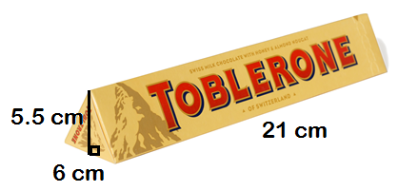

1. Toblerones in a shipping carton.  
   1. Draw a diagram, of how the Toblerones would be packaged within the shipping carton. Ensure you clearly label or indicate or explain:
      * The number of Toblerones in a row
      * How the boxes would be positioned
      * The number of layers
   2. What is the maximum number of Toblerones that can fit into one shipping carton? Ensure you show your working.

**Question 3 (8 marks:3, 3, 2)**

Juice boxes are transported in open trays, as shown in the diagram below.

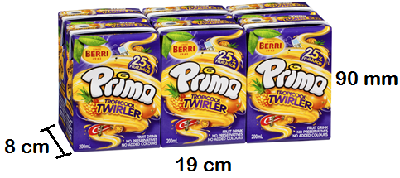

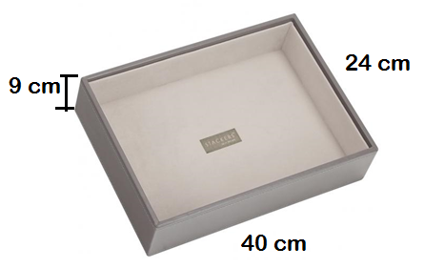

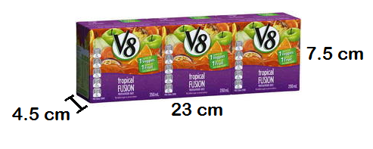

1. A pack of juice boxes, as shown in the picture, contains 6 individual 200 mL boxes within the pack.   
   1. What is the maximum number of juice boxes can be transported within a tray?

* 1. What is the capacity of juice within the tray in litres?

1. Juice can also be packaged in packs 3 individual 250 mL boxes within the pack, as shown.
   1. What is the maximum number of juice boxes can be transported within a tray?

* 1. What is the capacity of juice within the tray in litres?

1. 1 millilitre = 1 gram. What is total weight, in kilograms, for a tray of juice boxes in a:
   1. 6 pack

* 1. 3 pack